**Python Documention and Installation links**

To install the Python software below is the link. Download the latest version and install:

<https://www.python.org>

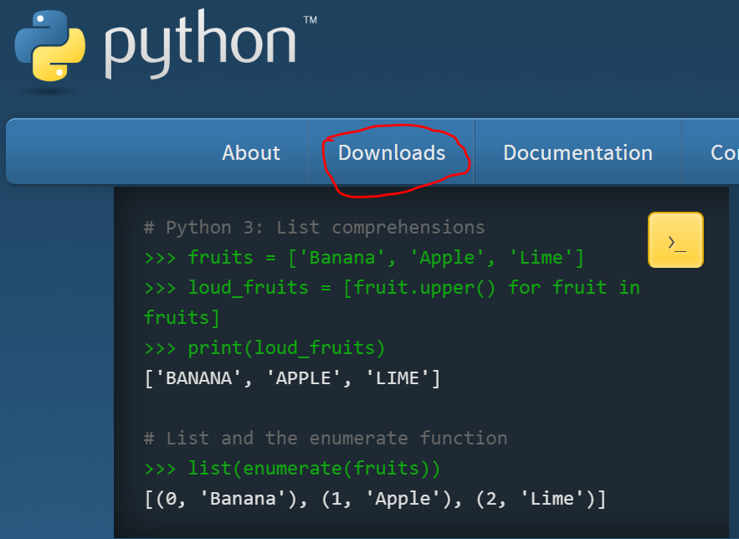

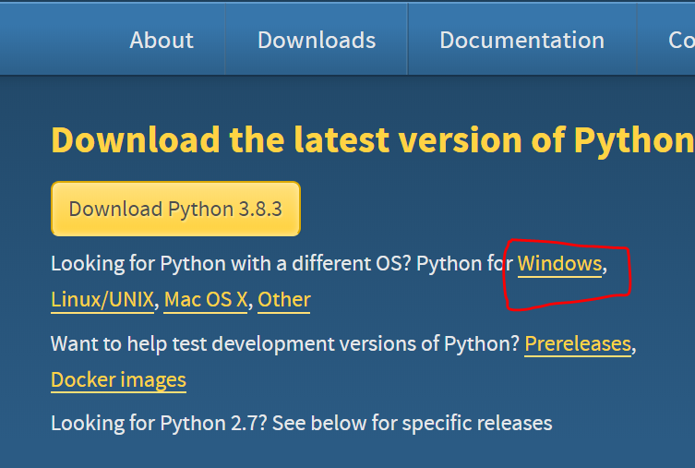

Python Examples and Documentation is available in the below path:

<https://www.python.org/doc>

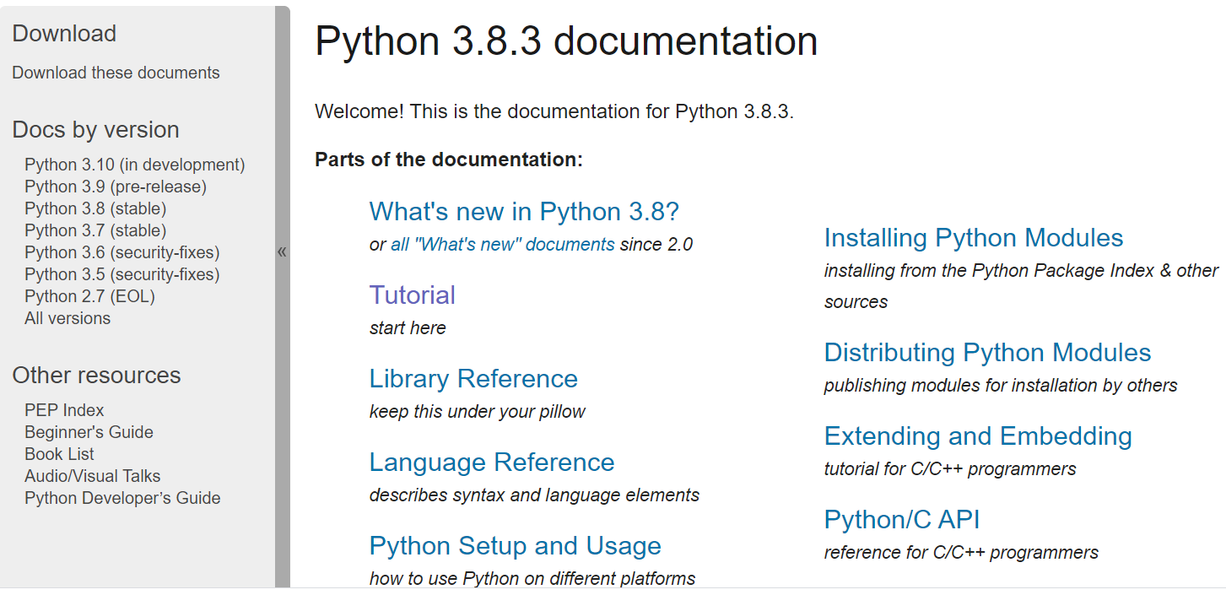

To install IDE for writing the code below is the link:

<https://www.anaconda.com/products/individual>

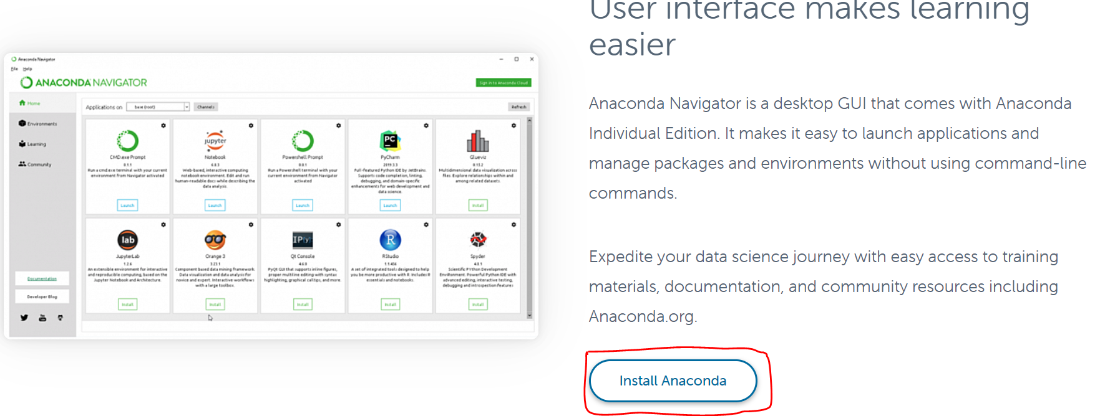

For any issues contact my email:

[Rajkumar.sairi@optum.com](mailto:Rajkumar.sairi@optum.com)